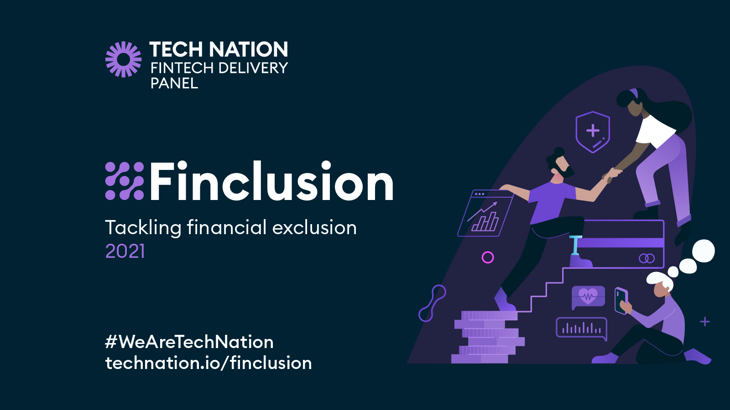

PARTICIPATION FORM FOR INDUSTRY EVENTS

Welcome to Finclusion 2021!

Finclusion 2021 is a series of connected happenings designed to stimulate, inspire, showcase and scale fintech’s contribution to financial inclusion – from potential game-changing products and collaborations, to the here-and-now actions being driven by the UK’s leading firms reshaping financial services.

Throughout November, Finclusion 2021 presents a month-long campaign including virtual and in-person workshops, show-and-tell events, and sprint challenges; with thought leadership and discussion across social and traditional media.

Finclusion 2021 aims to:

- Raise awareness of financial exclusion challenges, spotlight fintech solutions, and inspire and scale new innovation
- Deliver results with real action to directly solve financial inclusion challenges to the benefit of end consumers
- Promote collaboration across the UK fintech ecosystem with a call to action for the common good

PARTICIPATION FORM
A. About your organisation
Organisation:
Lead contact name:
Lead contact job title:
Lead contact email:
Lead contact phone number:
Additional contacts name/email:
B. Focus area
Please describe the specific area of financial inclusion that your activity seeks to address
Which category below does this fall into?
Vulnerability
Accessibility and Product Suitability
Health and Wellbeing
Affordable Credit and Insurance
Financial Resilience and Capability
C. Details of planned activity
What is the format of your Finclusion 2021 activity? Please share as much detail as you are currently able to provide to help us understand the nature of your activity.
E.g. Hackathon, innovation challenge (internal/external), research launch, demo day, product launch/enhancement, sharing best practice, roundtable debate
Time/Date:
Online or in person?
Anticipated number of participants/audience
D. Finclusion Principles There is no charge to participate in Finclusion 2021. However we ask that all participating organisations demonstrate alignment with the campaign principles outlined below.
Principle 1. Ideation & Inspiration - How will your activity directly help to address a financial inclusion challenge, or inspire action to develop future solutions?
Principle 2. Collaboration - including lived experience/customer input
How will you work with others to inspire/develop/deliver solutions to your identified financial exclusion challenge? In particular are you already working with, or advised by, a third sector organisation, consumer rep or lived experience expert to inform your activity?
If yes - who/which organisation?
If no - would you like us to connect you with relevant lived experience experts or civil society organisations in the Finclusion network?
Principle 3. National - How will you make your activity accessible to a range of stakeholders from across the UK?
Principle 4. Outcome-focused - What will be the outcomes and who is the intended beneficiary? How will your activity create momentum towards change that goes beyond a single event or point in time?
E. Marketing and promotion
All Finclusion activity will be included on programme on the campaign website.
Short description of your activity/event (c.50-100 words)
Web page link for event registration
Permission to include logo on Finclusion campaign website
(please attach high res logo)
Organisation Twitter handle
Organisation LinkedIn profile
Media/PR colleague contact:

Thank you for your interest in participating in Finclusion 2021. The Tech Nation Fintech Delivery Panel team will be in touch shortly to discuss your planned activity.

We look forward to working with you on the campaign!

